COMPOUND MEASURES
Pearson Edexcel – Tuesday 19 May 2020 - Paper 1 (Non-Calculator) Higher Tier
1.
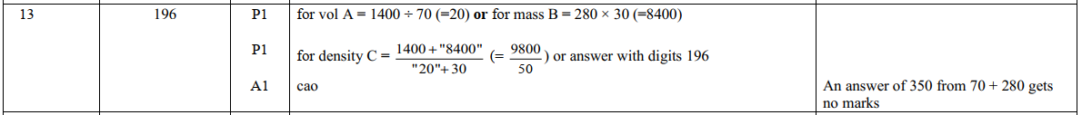
Pearson Edexcel - Tuesday 21 May 2019 - Paper 1 (Non-Calculator) Higher Tier
2.
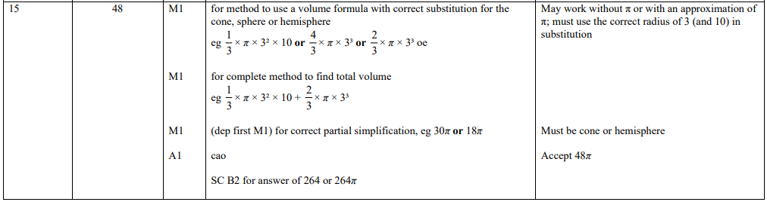
Pearson Edexcel - Tuesday 11 June 2019 - Paper 3 (Calculator) Higher Tier
3.
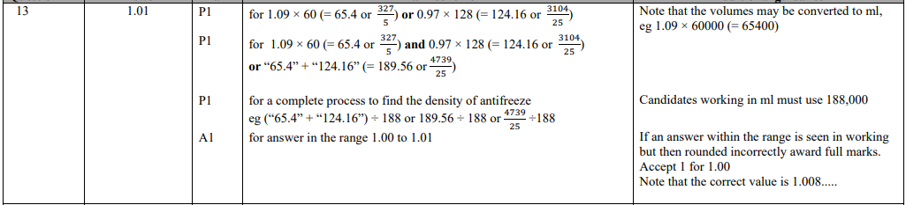
Pearson Edexcel - Thursday 8 November 2018 - Paper 2 (Calculator) Higher Tier
4.
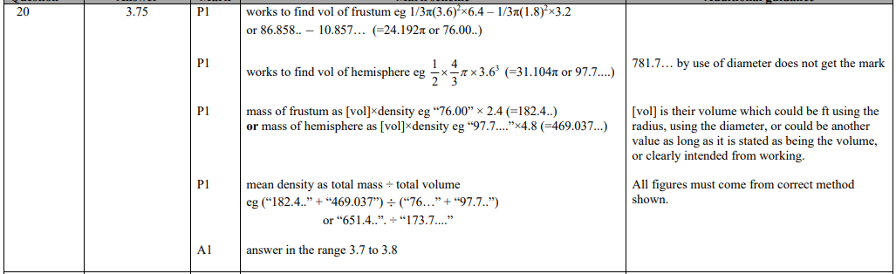
Pearson Edexcel - Thursday 7 June 2018 - Paper 2 (Calculator) Higher Tier
5.
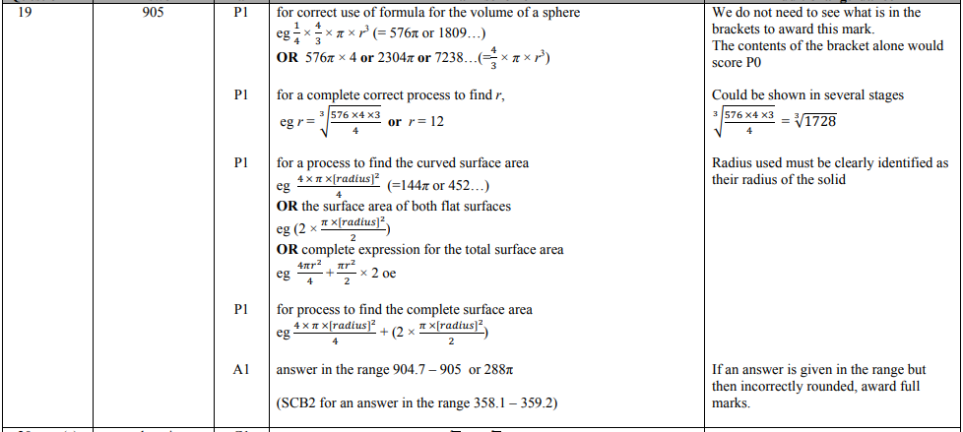
Pearson Edexcel - Tuesday 13 June 2017 - Paper 3 (Calculator) Higher Tier
6.
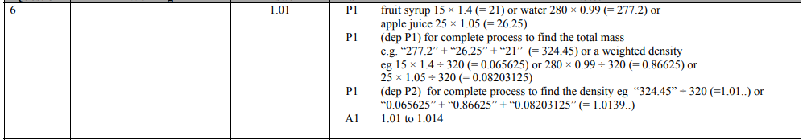
Pearson Edexcel - Specimen Papers Set 2 - Paper 3 (Calculator) Higher Tier
7.
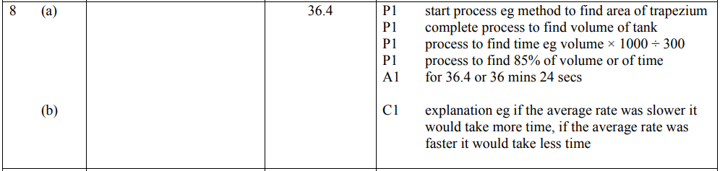
Pearson Edexcel - Specimen Papers Set 2 - Paper 3 (Calculator) Higher Tier
8.
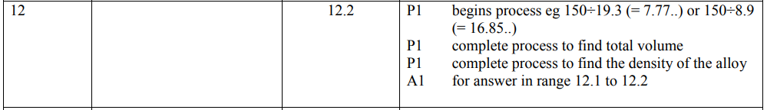
Pearson Edexcel - Specimen Papers Set 1 - Paper 3 (Calculator) Higher Tier
9.
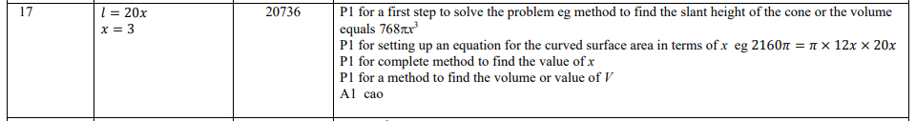
Pearson Edexcel - Thursday 9 June 2016 - Paper 2 (Calculator) Higher Tier
10.
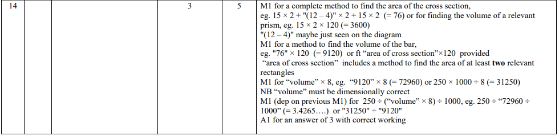
Pearson Edexcel - Wednesday 4 November 2015 - Paper 1 (Non-Calculator) Higher Tier
11.
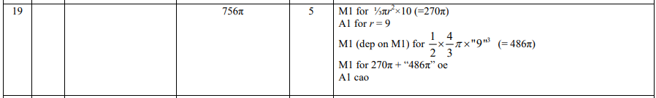
Pearson Edexcel - Monday 8 June 2015 - Paper 2 (Calculator) Higher Tier
12.
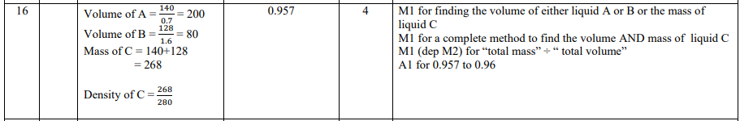
Pearson Edexcel - Wednesday 5 November 2014 - Paper 1 (Non-Calculator) Higher Tier
13.
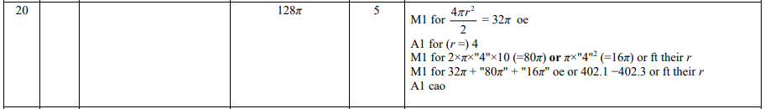
AQA GSCE – Tuesday 21 May 2019 – Paper 1 (Non - Calculator) Higher Tier
14.
